PRESS RELEASE

Patchogue Family YMCA Celebrates 15 Years of Serving the Community
PATCHOGUE, NY- September 10,2025 – On Wednesday, September 10, 2025, the Patchogue Family YMCA proudly celebrated its 15th Anniversary of serving the local community. The milestone event highlighted the Y’s impact over the past decade and a half, featuring a commemorative video showcasing achievements, programs, and inspiring member testimonials.
The celebration included remarks from John Borromeo, Executive Director of the Patchogue Family YMCA; Anne Brigis, President and CEO of the YMCA of Long Island; and Jim Folks, Patchogue Family YMCA, Chair of the Board. Together, they reflected on the Y’s journey since its opening, its role in empowering individuals and families, and its commitment to addressing the evolving needs of the Patchogue community.
“We knew from for the first time, the vision was clear to create a place where young people can grow their confidence, for families to come together and for neighbors to come and live healthier and stronger lives. For 15 years, that vision has become a reality through youth development, social responsibility and healthy living.” said John Borromeo, Executive Director of the Patchogue Family YMCA. “Let’s also look ahead, the world may change and challenges may come, but the mission of nurturing youth, strengthening community and promoting healthy living will remain important as ever.”
The Patchogue Family YMCA first opened its doors in 2010 and has since expanded its reach through innovative programs in youth development, healthy living, and social responsibility. Today, the branch continues to serve as a hub for wellness, family connection, and community engagement.
“When we opened the Patchogue YMCA, we knew that we were opening more than just community center, it was a turning point for the community and village, The Y became an anchor point in this transformation,” said Anne Brigis, President and CEO of the YMCA of Long Island.

About the YMCA of Long Island
The YMCA of Long Island is a 501(c)(3) nonprofit community-based service organization committed to strengthening communities through programs that nurture youth development, foster healthy living, and promote social responsibility. With locations in Bay Shore, East Hampton, Glen Cove, Holtsville, Huntington, and Patchogue, the YMCA empowers individuals and families to live healthier, more connected lives. Learn more at ymcali.org.

Photos:
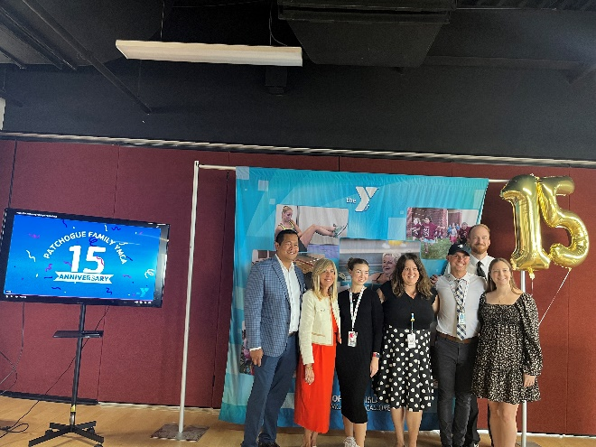
Photo 1: Staff Photo
L to R: John Borromeo, Executive Director, Patchogue Family YMCA, Anne Brigis, YMCA of Long Island CEO, Isabella Gaskill, Aquatics Coordintor, Tina Norbut, Senior Director of Youth Programs, Timothy McGoldrick, Membership, Darryl Smith, Program Director, Brittany Kontos, Health & Wellness Director
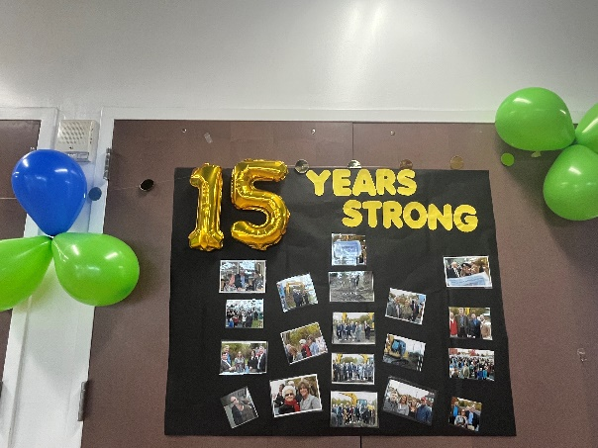
Photo 2: Patchogue Family YMCA throughout their 15 Years

