FOR IMMEDIATE RELEASE
100-Year-Old Member of Great South Bay YMCA Celebrates Birthday and can do a 3-Minute Plank
Bay Shore, NY – April 11, 2025 – Most people celebrate their 100th birthday with cake and candles—but Geraldine "Jerry" Leo, a longtime member of the Great South Bay YMCA, marked the milestone in true Y fashion: by holding a three-minute plank.
Yes—three minutes. At 100 years old.
A beloved figure in the Great South Bay YMCA community, Jerry has been inspiring fellow members and staff with her energy, strength, and can-do attitude for decades. Known for her commitment to wellness and joyful presence, she chose to celebrate a century of life by showing that age is no limit when it comes to fitness.
Her secret to longevity? “Just keep moving,” Jerry said. She participates every week for cardio fitness classes, TRX training, and planks—often outlasting people decades younger. “The Y has been a big part of my life. I love it here. I come here to exercise, but that is only a part of it,” Jerry said.
“Jerry is the embodiment of everything the Y stands for,” said Anne Brigis, President & CEO, YMCA of Long Island. “She shows us what’s possible when you stay active, stay connected, and never stop moving. Her energy, strength, and spirit inspire our entire community—staff and members alike. We’re honored to have her as part of our Y family.”
Over the years, Jerry has become a familiar face at the Y, building friendships and setting an incredible example of healthy aging. Her dedication to wellness, laughter, and community connection shows that the journey to lifelong health doesn’t stop at any age—it keeps going, plank by plank.
Jerry’s story is a testament to the importance of staying active, staying connected, and never underestimating what you can accomplish at any age.
To learn more about healthy aging programs and community offerings at the Great South Bay YMCA, visit ymcali.org.
About the YMCA of Long Island
The Great South Bay YMCA, part of the YMCA of Long Island, is committed to building healthy spirit, mind, and body for all. Through inclusive programs and community support, the Y empowers individuals and families to lead healthy, active lives at every stage.
The YMCA of Long Island is a 501c3 nonprofit community-based service organization dedicated to improving the lives of children, teens, adults, and families through programs and services that nurture youth development, foster healthy living, and inspire social responsibility. Long Islanders learn to live their healthiest and fullest lives inside the YMCA’s located in Bay Shore, East Hampton, Glen Cove, Holtsville, Huntington, and Patchogue. For information and locations, visit ymcali.org.

Photos/Video/Links:

Photo1: Jerry’s 100th Birthday Celebration April 11
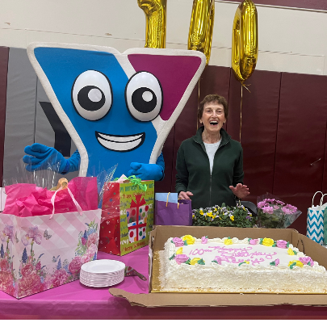

Photo 2: Jerry and Y Team pose for photo. Pictured left to right: Despina Tenedorio, Health & Wellness Director Great South Bay YMCA, Angie Carpenter, Town of Islip Supervisor, Jerry Leo, Great South Bay YMCA Charter Member, Anne Brigis, CEO & President of YMCA of Long Island, Bob Petterson, Executive Director, Great South Bay YMCA

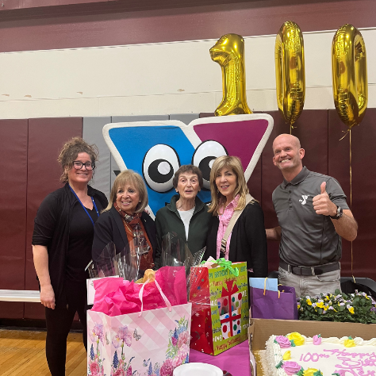

Video 1: Member Spotlight

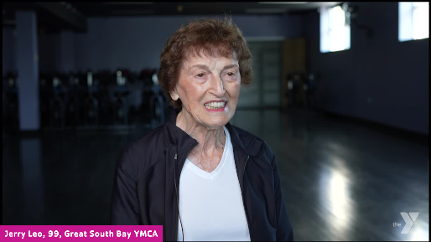

Photo 4: Jerry Holding Plank on her 100th birthday on April 11!
